**Module 6 JAVASCRIPT**

**Q.66 Find the length of a string without using libraryFunction?**

1. **What is JavaScript?**

**Ans:** JavaScript is a versatile programming language primarily used for creating interactive effects within web browsers. It's commonly used for web development alongside HTML and CSS.

JavaScript allows developers to add functionality to web pages, such as handling user input, modifying page content dynamically, and communicating with servers to fetch and send data without reloading the entire page.

1. **What is the use of isNaN function?**

**Ans:** isNaN() returns true if a number is Not-a-Number.

The isNaN() method converts the value to a number before testing it.

* // This returns true;

isNaN('Hello');

* // This returns false;

1. **What is negative Infinity?**

**Ans:** NEGATIVE_INFINITY is a special numeric value that is returned when an arithmetic operation or mathematical function generates a negative value greater than the largest representable number in JavaScript.

1. **Which company developed JavaScript?**

**Ans:** JavaScript was developed by Netscape Communications Corporation, specifically by Brendan Eich. It was initially created under the name "Mocha" by Eich in just ten days in 1995. Later it was renamed to "LiveScript" and then finally to "JavaScript".

1. **What are undeclared and undefined variables?**

**Ans:** Undefined: It occurs when a variable has been declared but has not been assigned any value. Undefined is not a keyword. Undeclared: It occurs when we try to access any variable that is not initialized or declared earlier using the var or const keyword.

1. **What is the difference between ViewState and SessionState?**

**Ans:** ViewState and SessionState are used for client-side state management and server-side state management respectively. The basic difference between these two is that the ViewState is to manage state at the client’s end, making state management easy for end-user while SessionState manages state at the server’s end, making it easy to manage content from this end too.

1. **What is === operator?**

**Ans:** The strict equality (===) operator checks whether its two operands are equal, returning a Boolean result. Unlike the equality operator, the strict equality operator always considers operands of different types to be different.

1. **How can the style/class of an element be changed?**

**Ans:** You can change the style of an element by directly manipulating its style property. For example:

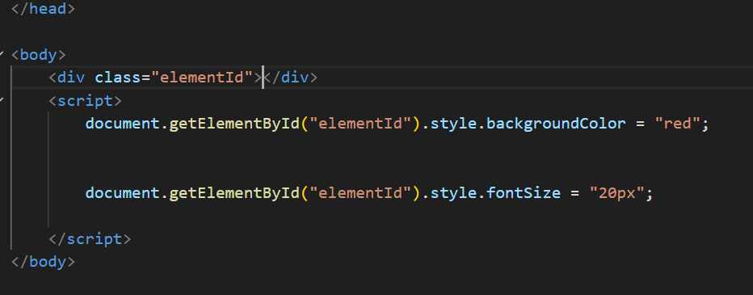

1. **What are all the looping structures in JavaScript?**

**Ans:**

**1 for loop:**

The for loop is one of the most commonly used looping structures. It iterates a block of code a specified number of times.

for (initialization; condition; iteration) {

// code to be executed

}

**2 while loop:**

The while loop iterates a block of code as long as the specified condition evaluates to true.

while (condition) {

// code to be executed

}

1. **What is the function of the delete operator?**

**Ans:** The delete operator in JavaScript is used to remove a property from an object. It can also be used to remove elements from an array.

However, it cannot be used to remove variables or functions declared with the var, let, or const keywords.

1. **What are all the types of Pop up boxes available in JavaScript?**

**Ans:**

**Alert Box:** The alert() method displays an alert dialog with a message and an OK button. It's primarily used for showing informative messages to the user.

**alert("This is an alert message!");**

**Confirm Box:** The confirm() method displays a dialog box with a message and two buttons: OK and Cancel. It's commonly used to ask the user for confirmation before proceeding with an action.

let result = confirm ("Are you sure you want to delete this item?”);

if (result) {

// Proceed with deletion

} else {

// Cancel deletion

}

1. **What is the use of Void (0)?**

**Ans:** In JavaScript, void(0) is a unary operator that evaluates the expression within the parentheses and then returns undefined. It's often used in scenarios where you want to create a hyperlink that doesn't navigate anywhere when clicked.

1. **How can a page be forced to load another page in JavaScript?**

**Ans:** In JavaScript, you can force a page to load another page by changing the window.location property to the URL of the page you want to load. This can be achieved using the assign() method of the window.location object.

1. **What are the disadvantages of using innerHTML in JavaScript?**

**Ans:**

The process of using innerHTML is much slower as its contents as slowly built.

The event handlers do not get attached to the new elements created by setting innerHTML automatically.

Either you add, append, delete or modify contents on a webpage using innerHTML, all contents is replaced, also all the DOM nodes inside that element are reparsed and recreated.

Usually, += is used for appending in JavaScript. But on appending to an Html tag using innerHTML, the whole tag is re-parsed.

**15. Create password field with show hide functionalities**

**Ans:**

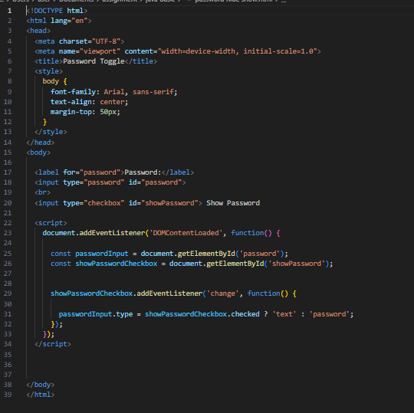

**Output:**

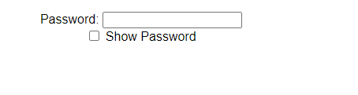

**16.Create basic math operation in JS**

**Ans:**

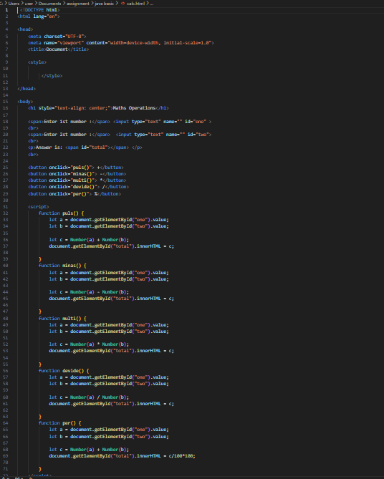

**Output:**

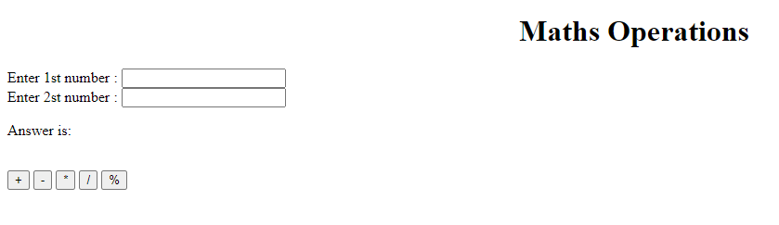

**17. Create result.**

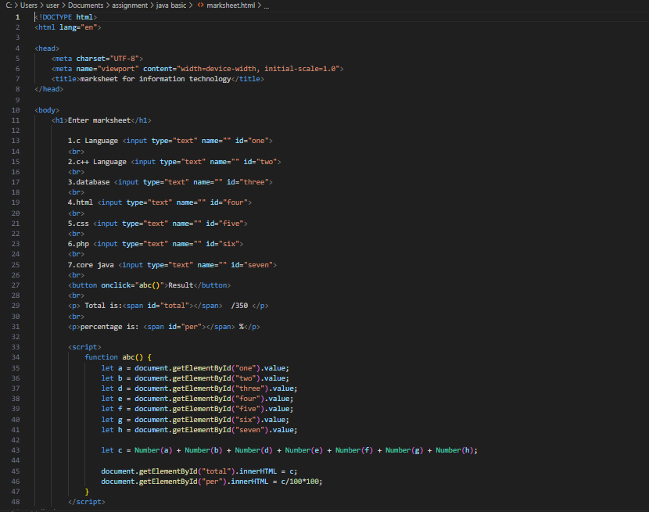

**Output:**

